**MASTERPIECES OF WESTERN ART**

Art Humanities W1121 Section 15

Spring 2013

Images to memorize for the mid-term exam, Monday March 11

**1. Parthenon**

Parthenon, Acropolis, Athens, 447-432 B.C. Architects: Iktinos and Kallikrates.

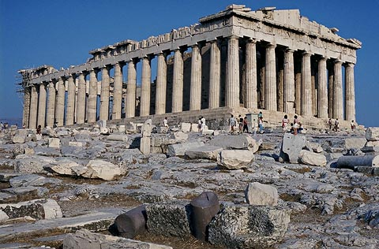

Phidias, *Athena Parthenos*, c. 440 B.C. (Reconstitution).

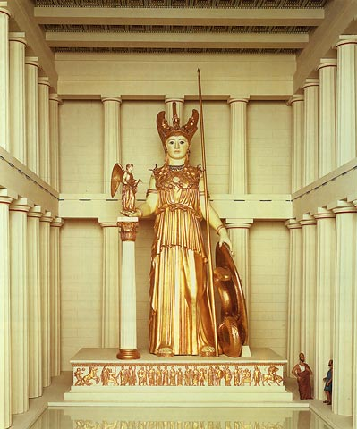

Parthenon, Acropolis, Athens, 447-432 B.C. View of the stylobate.

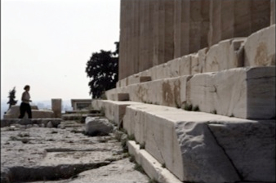

Parthenon, Acropolis, Athens, 447-432 B.C. Detail of the West façade.

*Note:* this image shows the Doric columns, the alternation of triglyphs and metopes (a feature of the Doric order), the pediment, and the Ionic frieze (in the background).

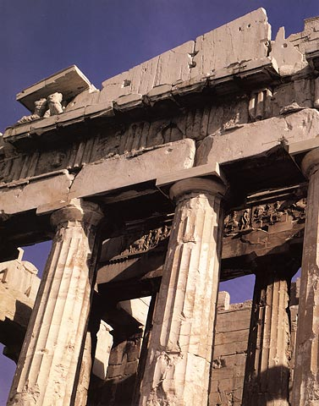

*Battle of Lapith and Centaur*, metope, Parthenon, Acropolis, Athens, 447-432 B.C.

*Note:* the sculptor Phidias conceived the sculptural program of the Parthenon; however, he did not carved himself all the sculptures.

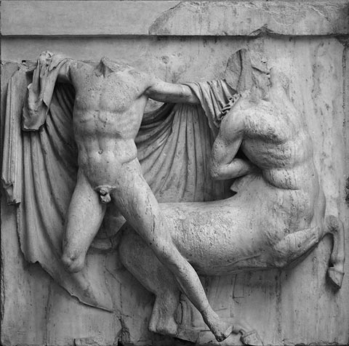

Unknown artist, Kouroi known as *The Twins of Argos*, c. 580 B.C.

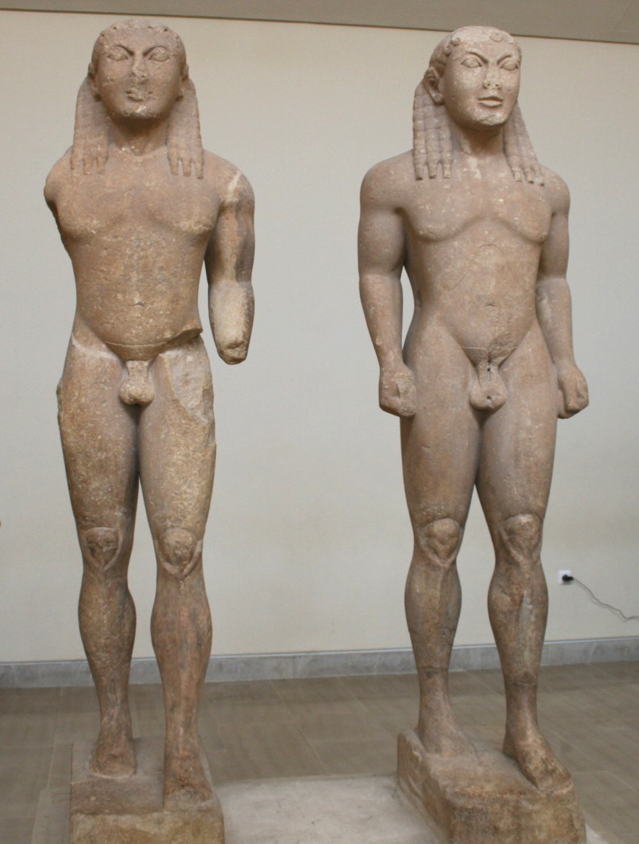

Polycleitos, *Doryphoros (Spear-Bearer)*, c. 440 B.C. (Roman copy).

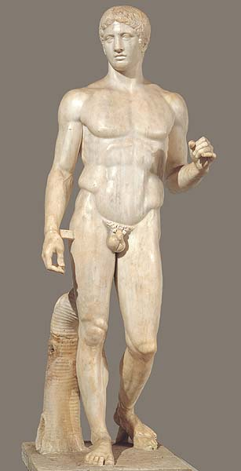

Unknown artist, *Peplos Kore*, colored reconstruction, originals c. 530 B.C.

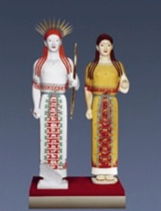

*Panathenaic Procession: Ritual Act with the Robe (Peplos) of Athena; Seated God and Goddess*, fragment of the Ionic frieze, Parthenon, Acropolis, Athens, 447-432 B.C.

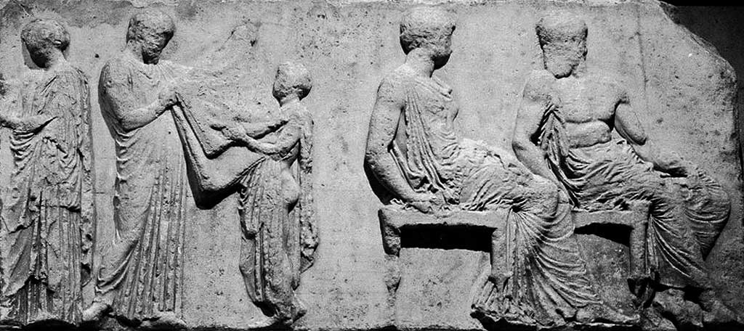

*Dione and Aphrodite* (?), pediment sculpture, Parthenon, Acropolis, Athens, 447-432 B.C.

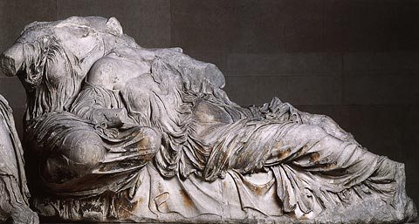

**2. Amiens Cathedral**

Notre-Dame Cathedral, Amiens, 1220-1269. West façade (portals/gallery of Kings & triforium/rose/towers).

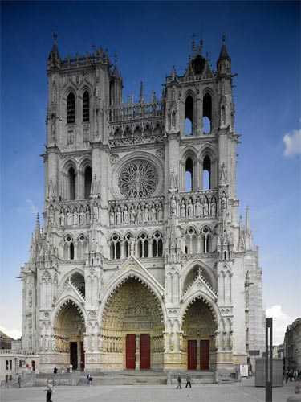

Notre-Dame Cathedral, Amiens, 1220-1269. The nave.

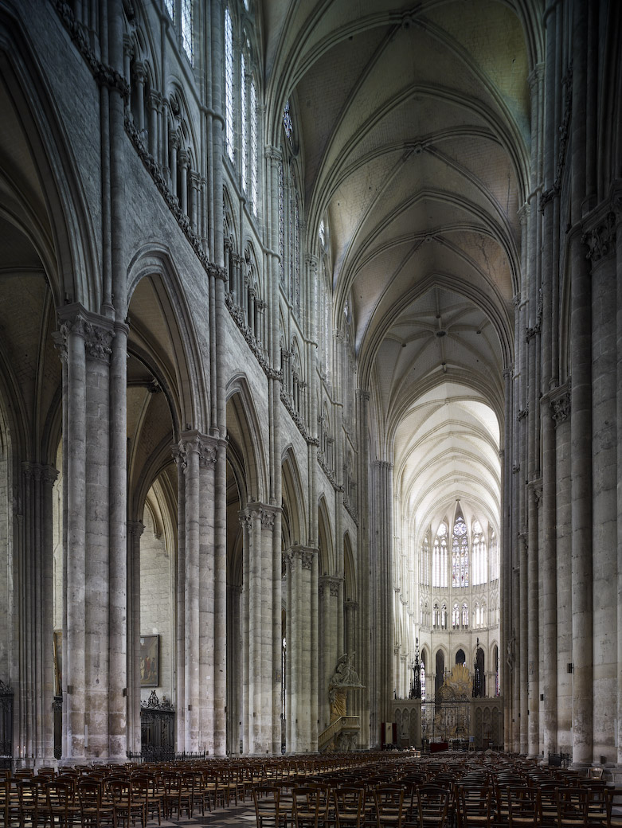

Notre-Dame Cathedral, Amiens, 1220-1269. Quadripartite rib vault.

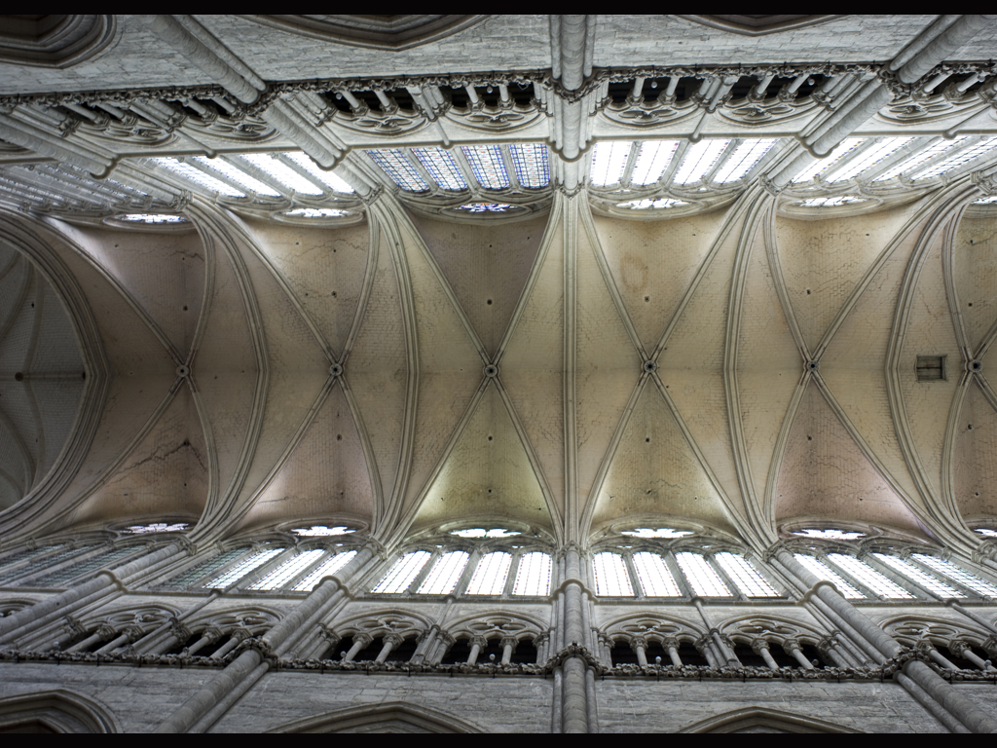

Notre-Dame Cathedral, Amiens, 1220-1269. Interior elevation (arcade/triforium/clearstory).

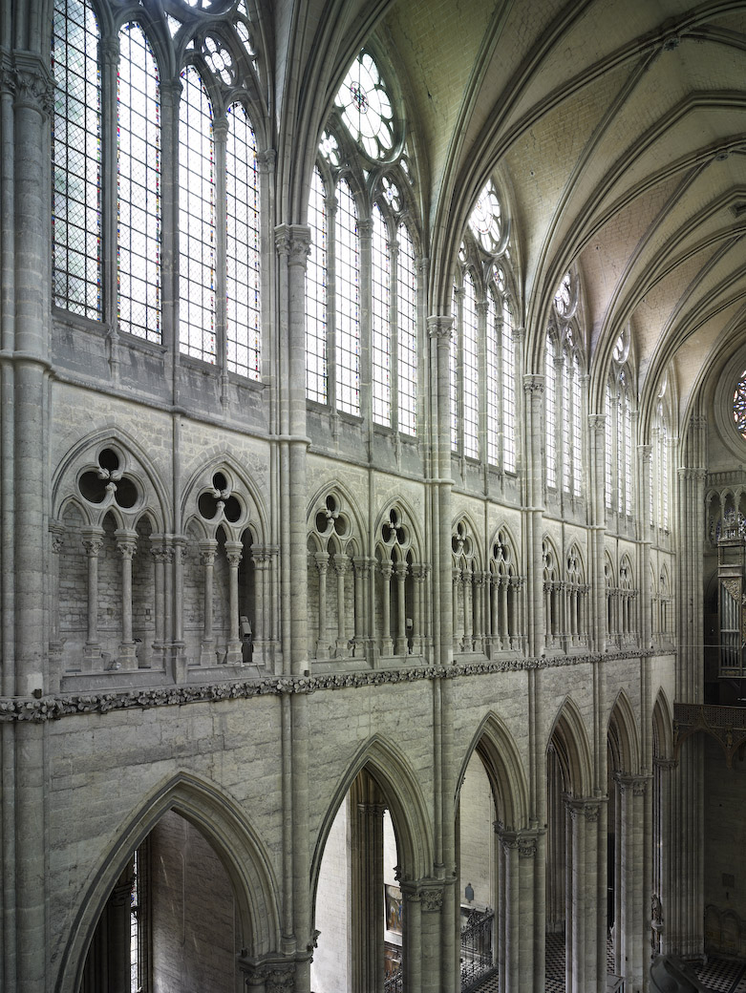

Portal of the Last Judgment, 1225-1250, Notre-Dame Cathedral, Amiens.

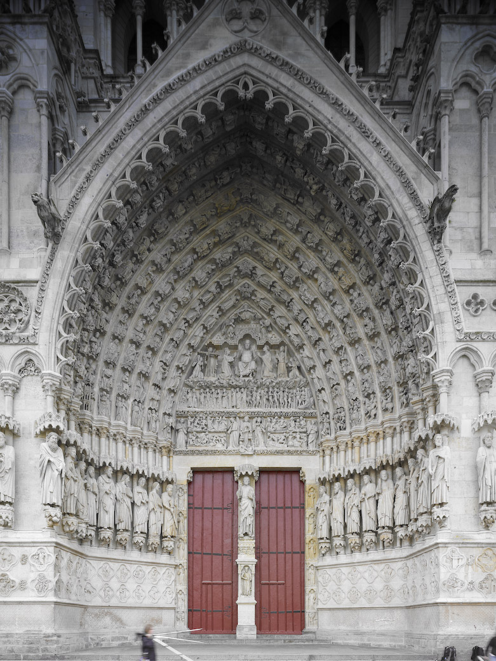

Detail of the Portal of the Last Judgment: The Damned Led to Hell; The Dead Resuscitate, 1225-1250, Notre-Dame Cathedral, Amiens.

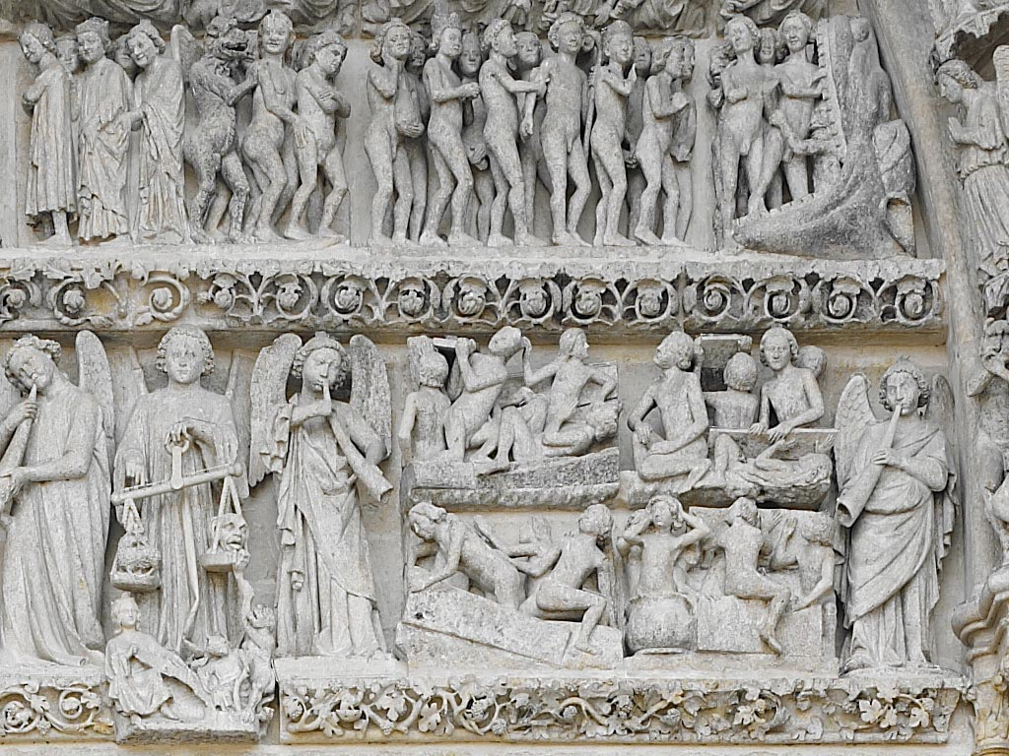

Andrea della Robbia, *Annunciation*, glazed terra-cotta, c. 1520.

*Note:* we looked at a similar glazed terra-cotta by della Robbia in Saint John the Divine.

This image is meant as a reminder of the iconography of the Annunciation.

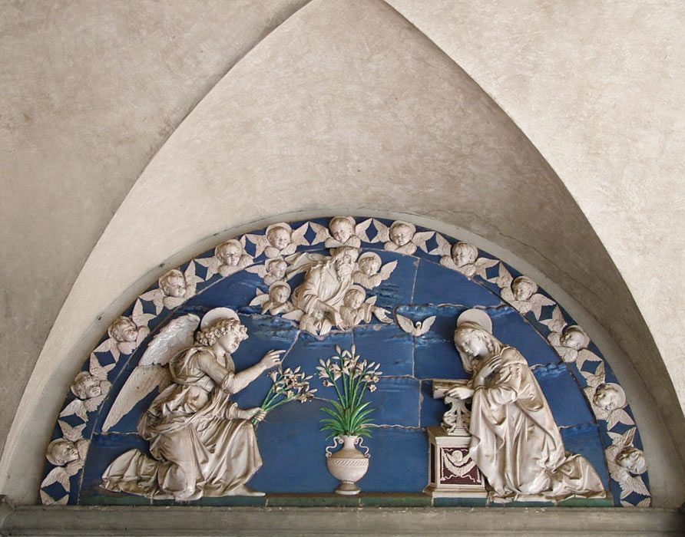

**3. Raphael**

Raphael, *The Dream of the Knight*, 1502-03.

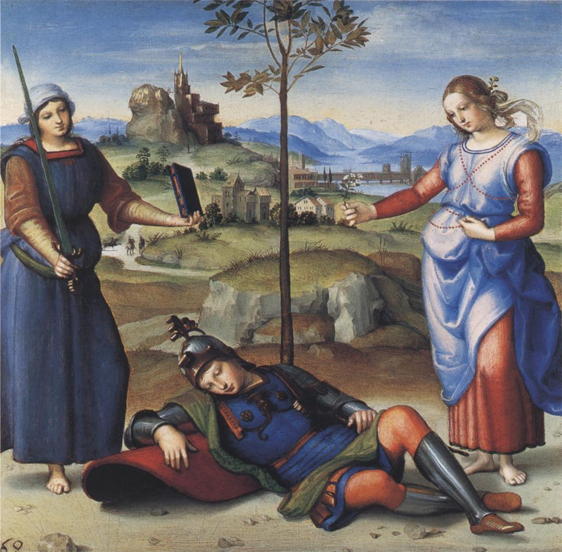

Raphael, *The Crucifixion*, c. 1502-03.

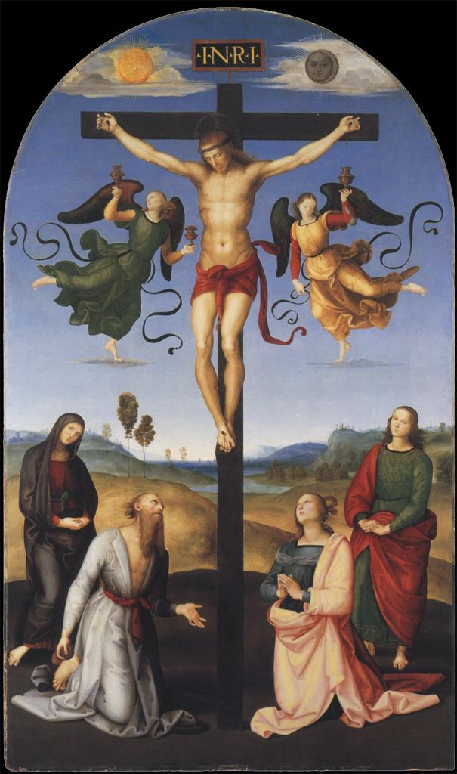

Raphael, *The Entombment*, 1507.

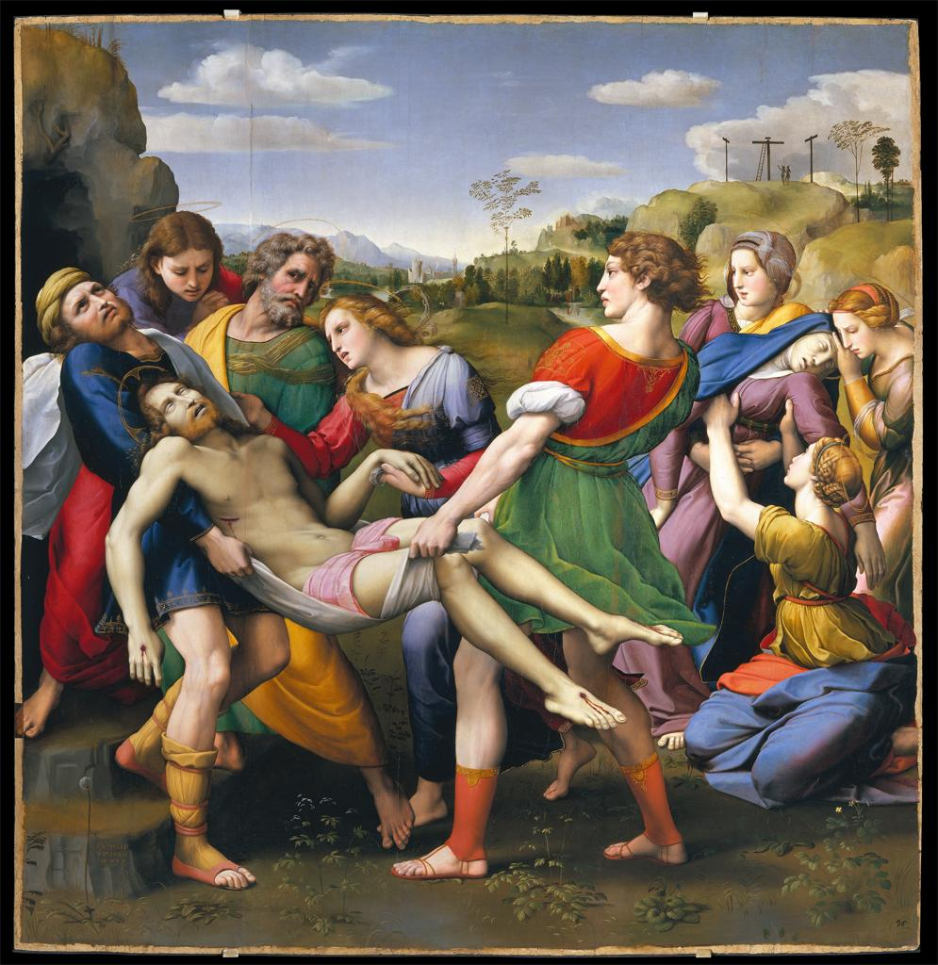

Raphael, Study for *The Entombment*, 1507.

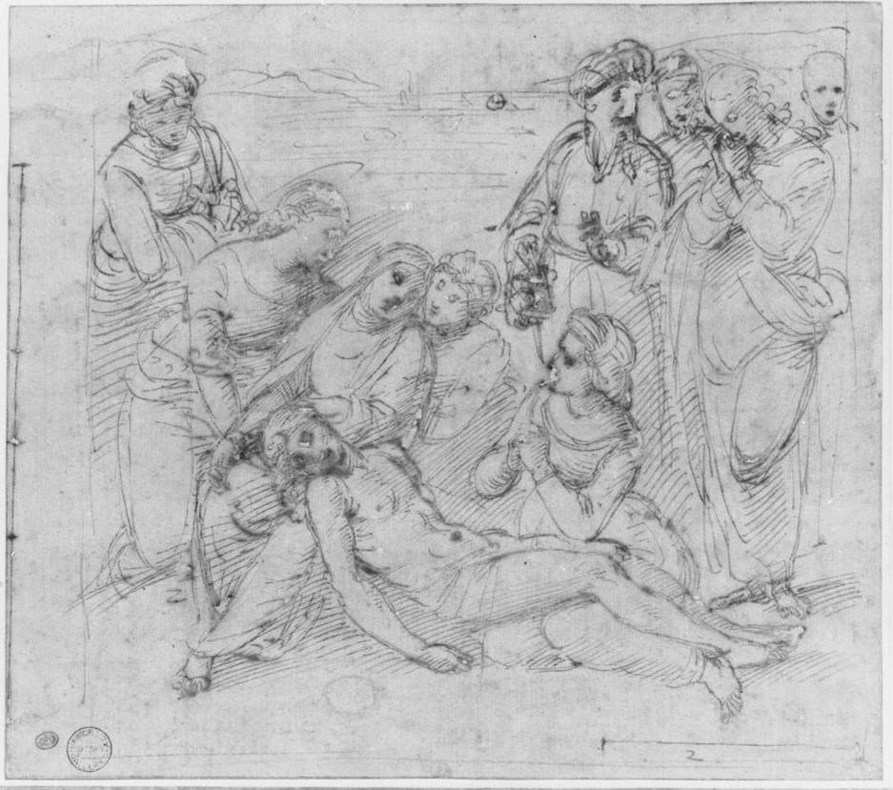

Leonardo, *Study for Madonna and Child with Saint Anne and John the Baptist*, 1500.

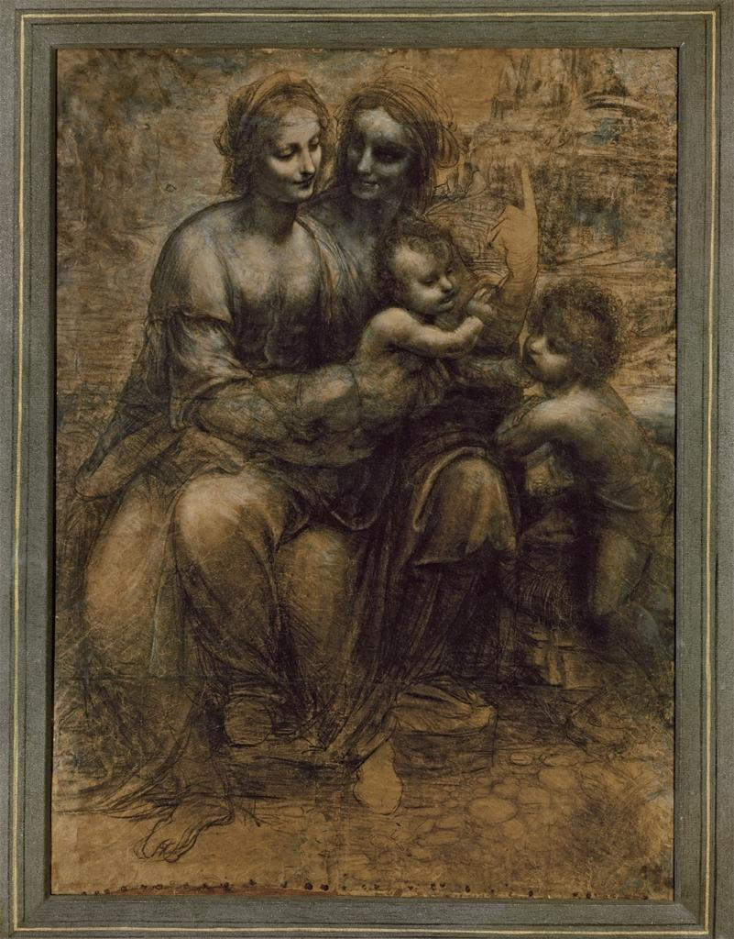

Raphael, *Study for Madonna and Child with John the Baptist*, c. 1507.

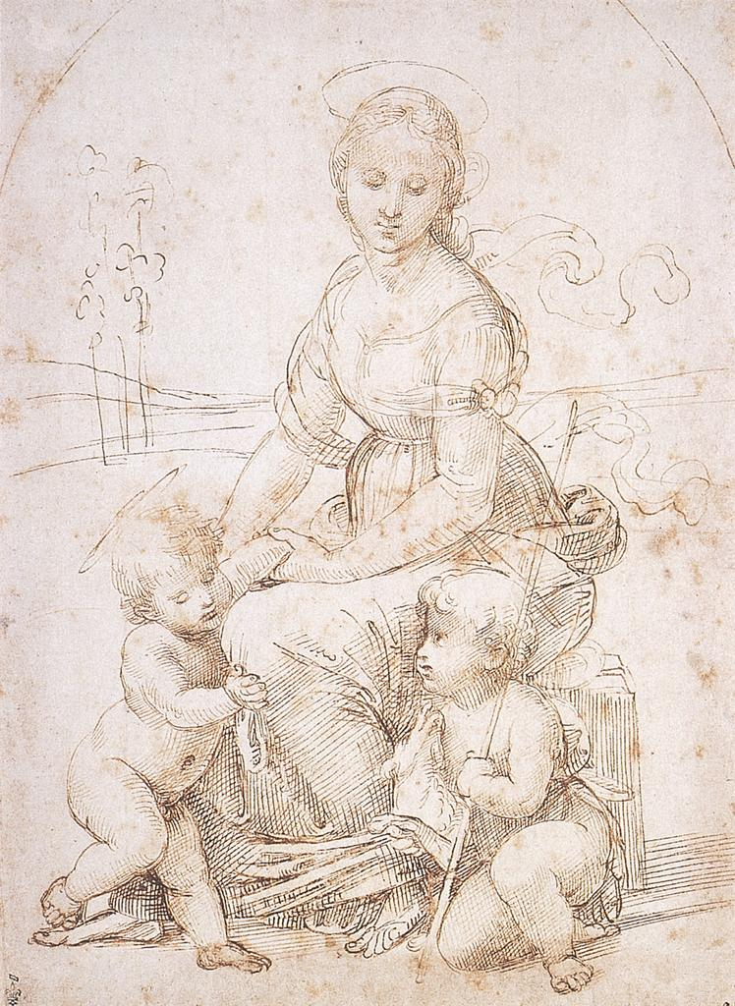

Raphael, *The School of Athens*, fresco, Stanza della Segnatura, Vatican Palace, Rome, 1508-12.

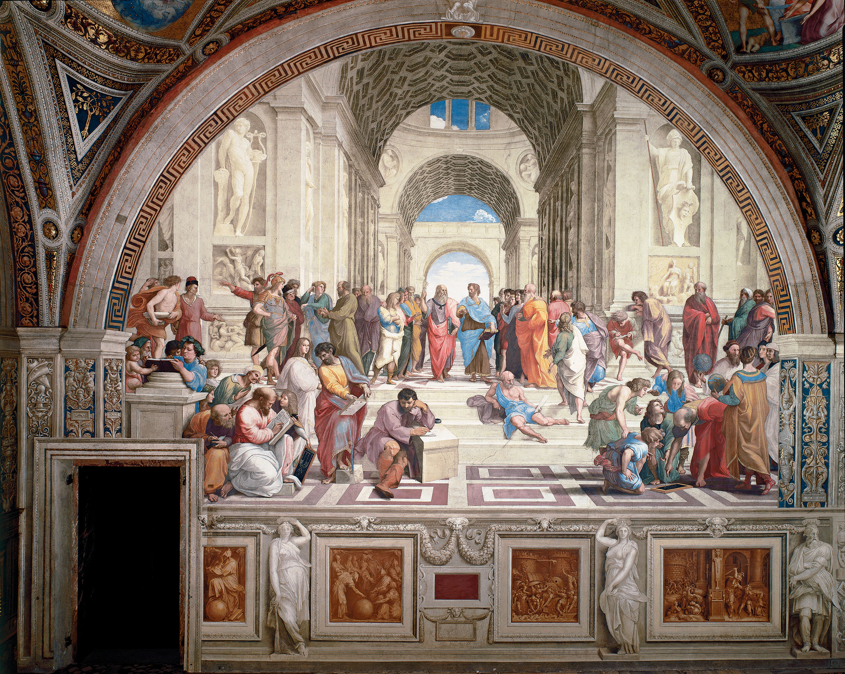

Raphael, *Disputa*, fresco, Stanza della Segnatura, Vatican Palace, Rome, 1508-12.

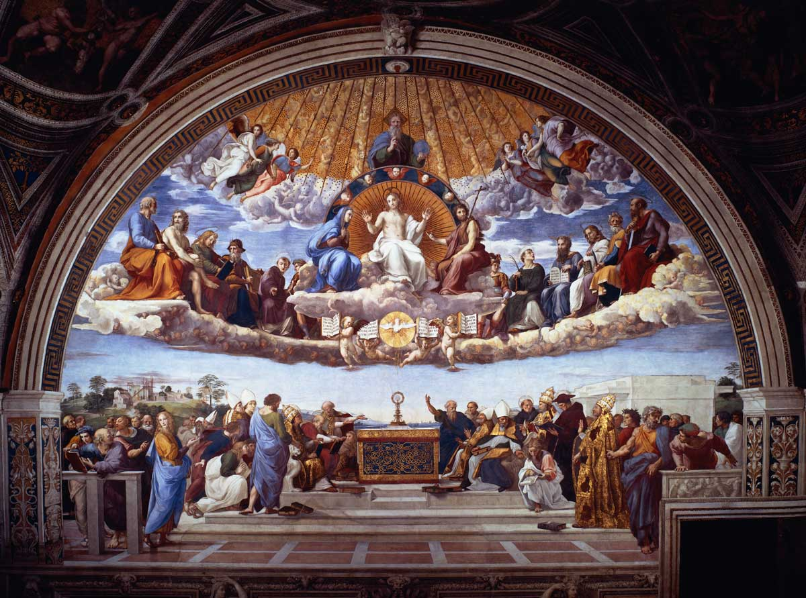

**4. Michelangelo**

Michelangelo, *The Last Judgment*, fresco, Sistine Chapel, Vatican Palace, Rome, 1535-41.

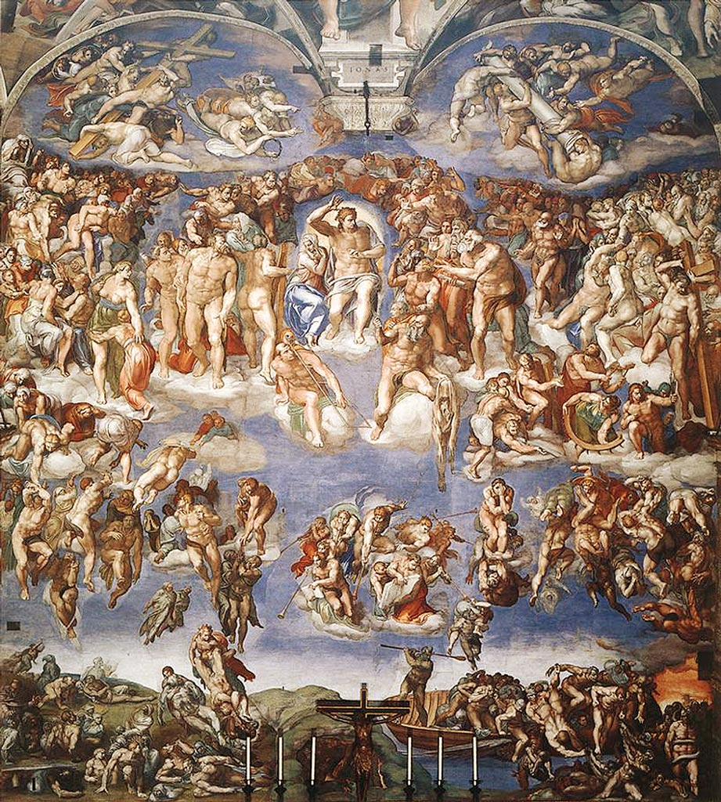

Michelangelo, *The Holy Family with John the Baptist*, c. 1503-04.

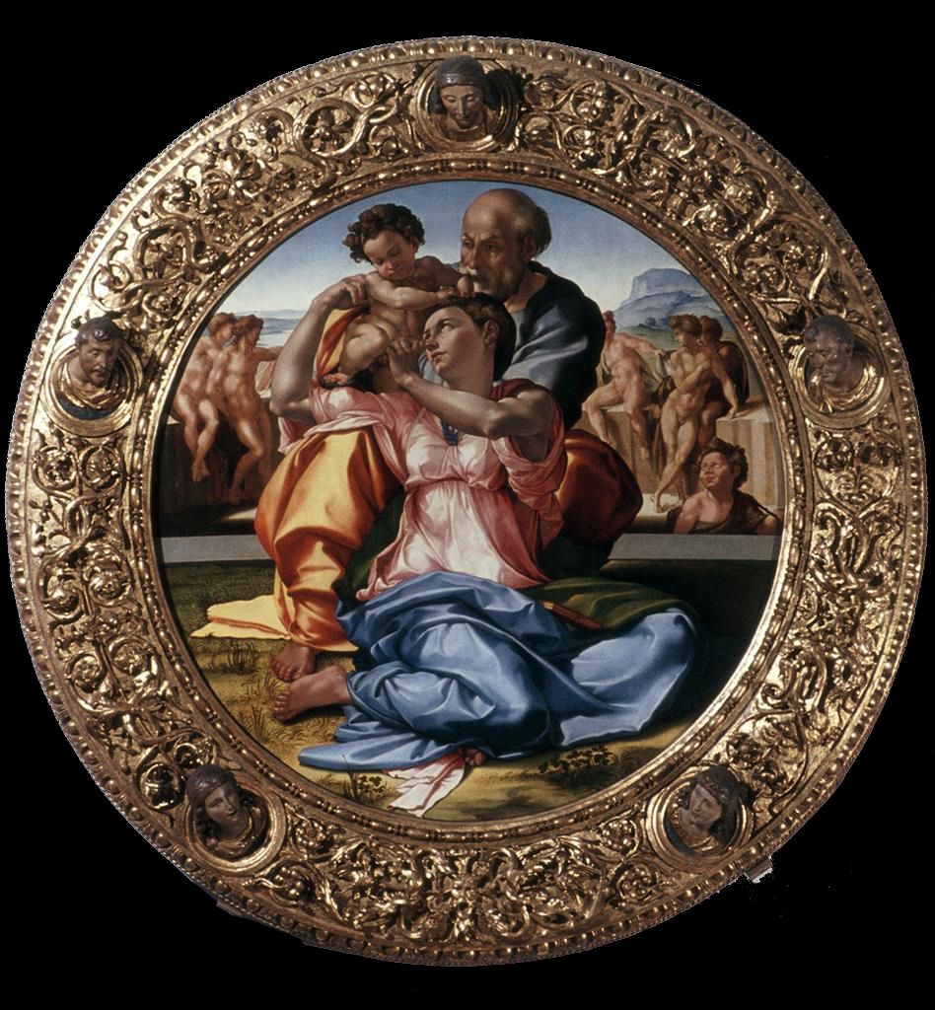

Michelangelo, Study for *The Libyan Sibyl* (final figure on the Sistine Chapel Ceiling), c. 1508-12.

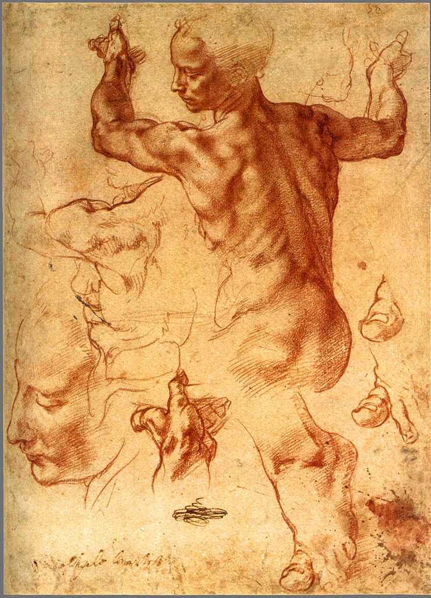

Michelangelo, *Bacchus*, 1496-97.

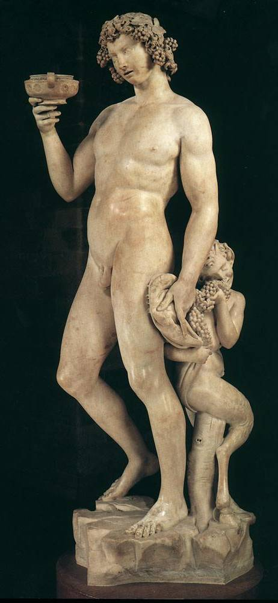

Michelangelo, *Battle of Lapiths and Centaurs*, 1492.

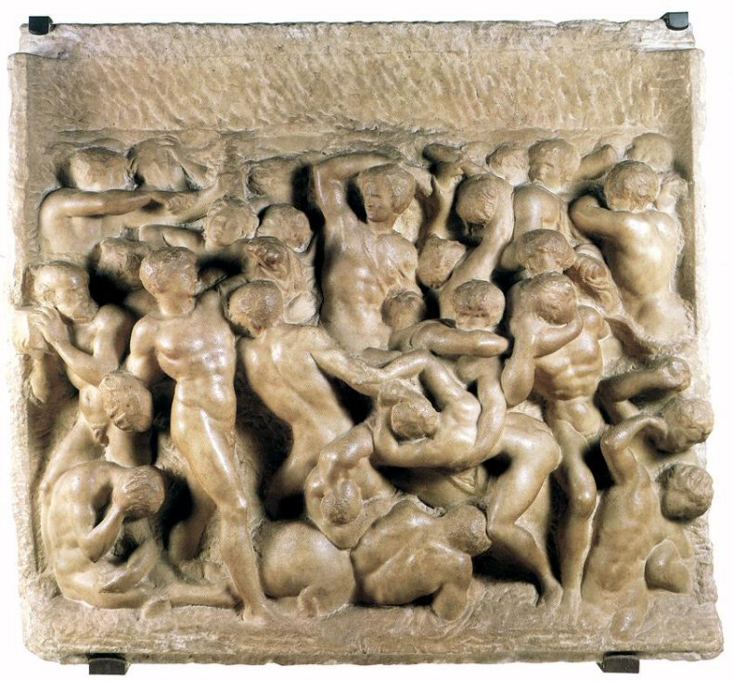

Michelangelo, *David*, 1501-04.

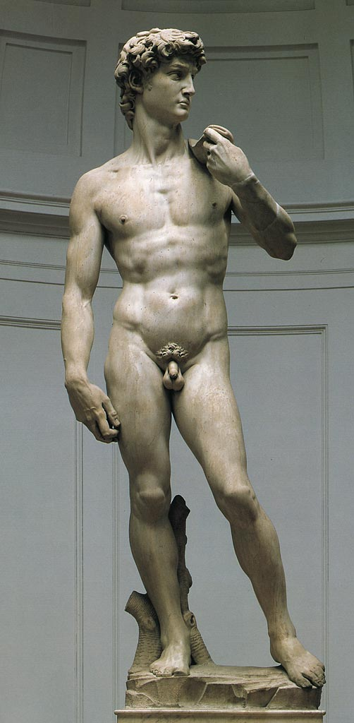

Michelangelo, *Moses*, c. 1515. For the tomb of Pope Julius II.

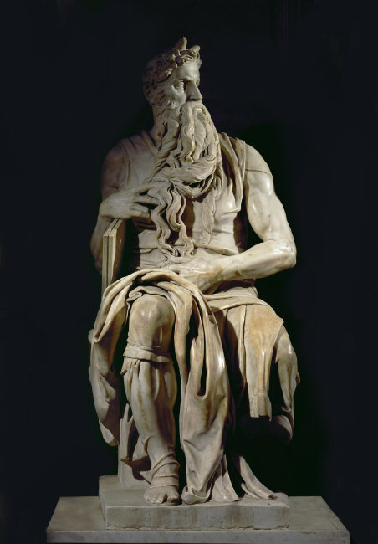

Michelangelo, *Awakening Slave*, c. 1516-19. For the tomb of Pope Julius II.

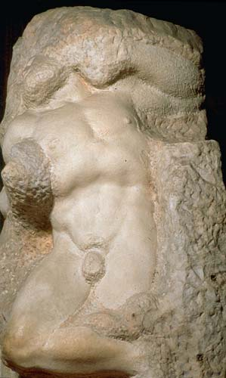

**5. Bernini**

Bernini, First Project for the East Façade of the Louvre, 1664.

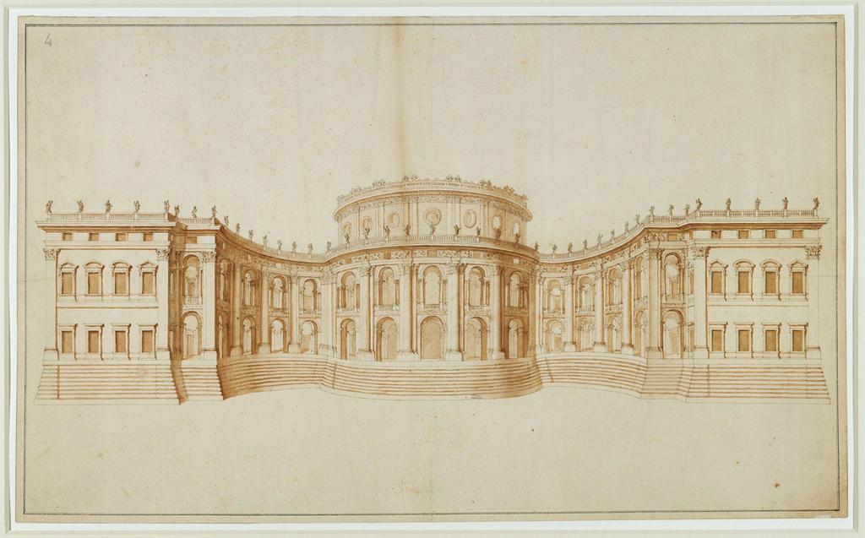

Bernini, *Portrait Bust of Louis XIV*, 1665.

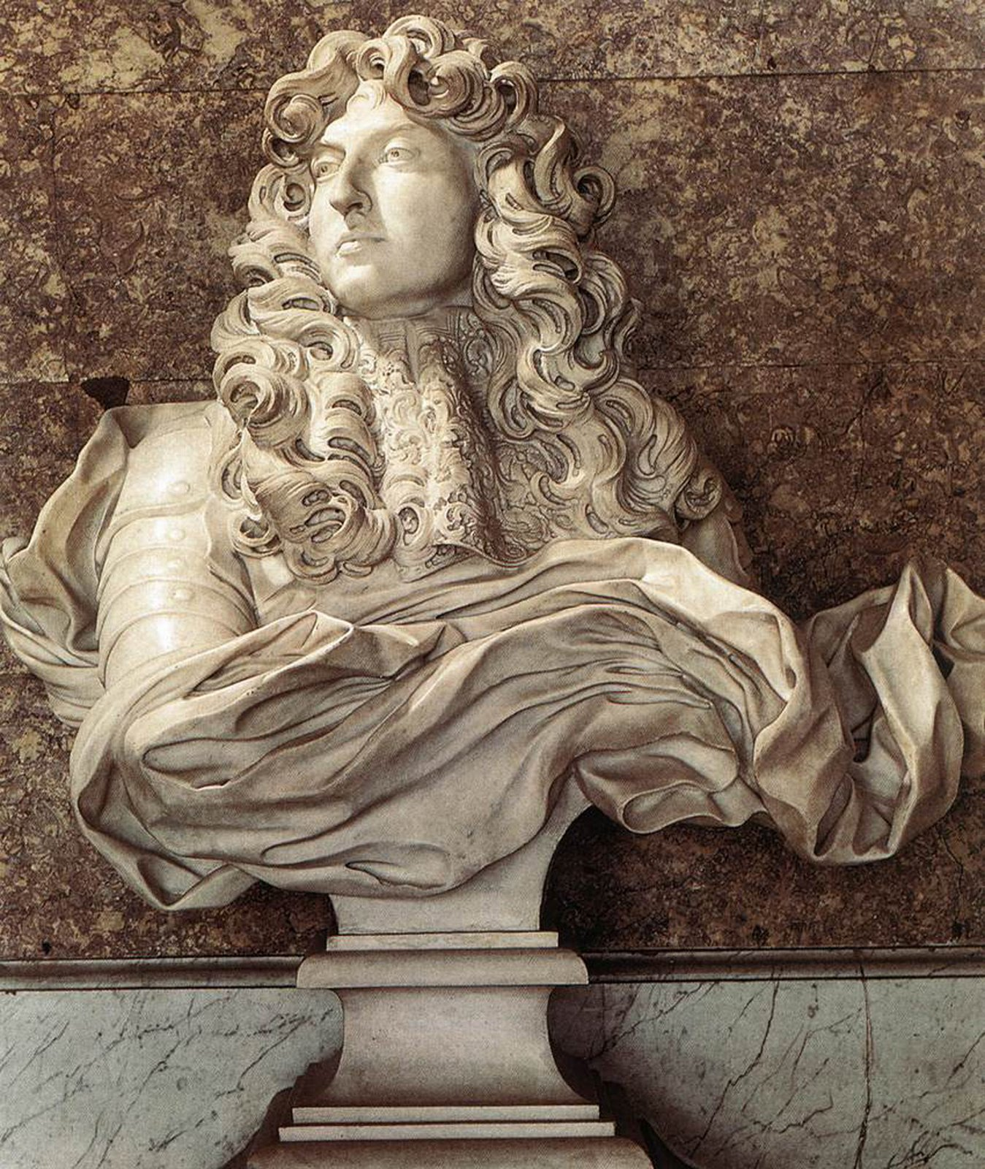

Bernini, *Portrait Bust of Costanza Bonarelli*, 1635.

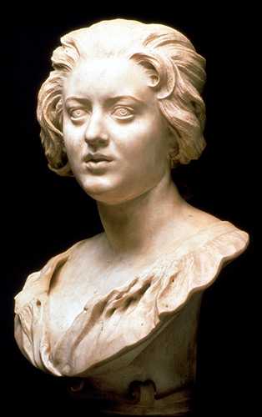

Bernini, *Ecstasy of Saint Theresa*, Cornaro Chapel, Santa Maria della Vittoria, Rome, 1645-52.

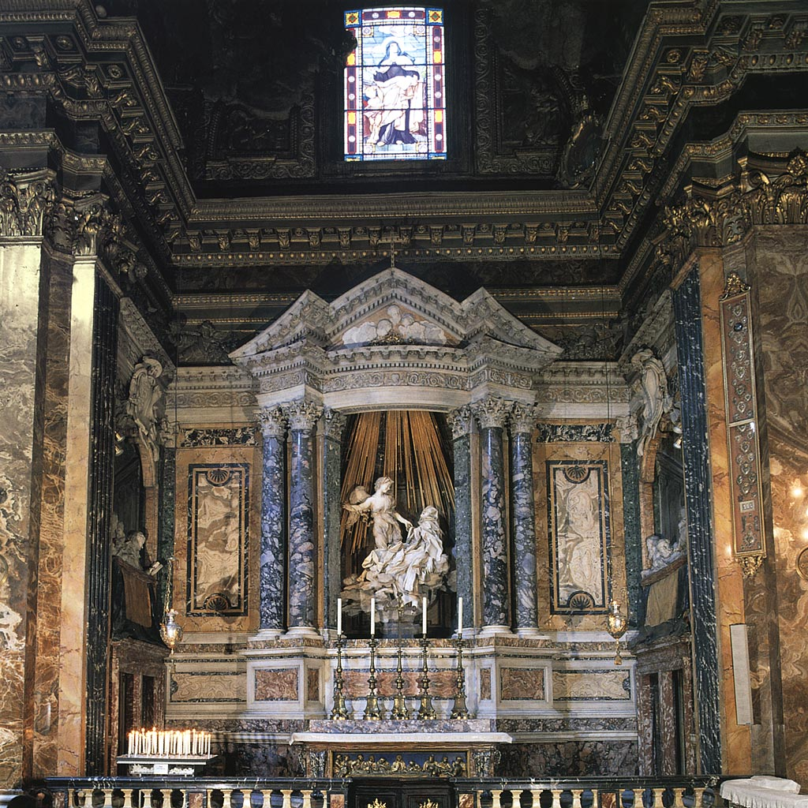

Bernini, *David*, 1623-24.

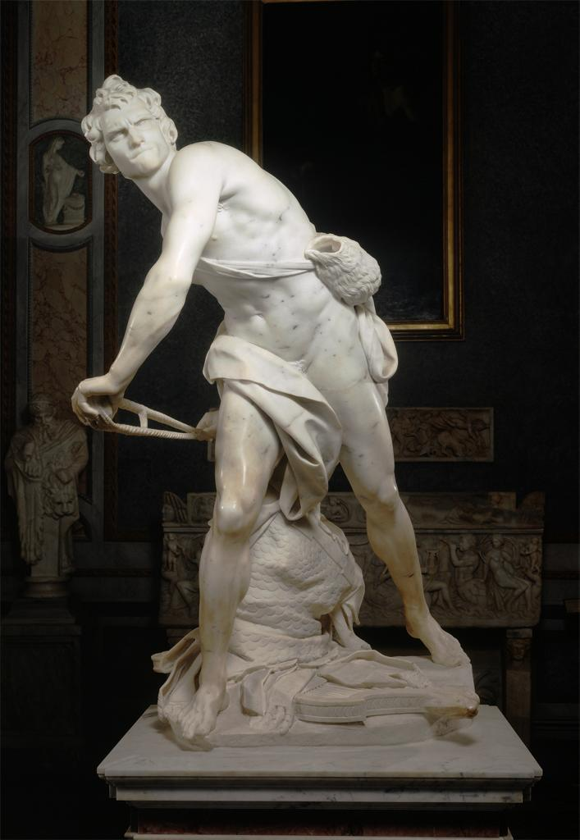

Bernini, *Apollo and Daphne*, 1622-25.

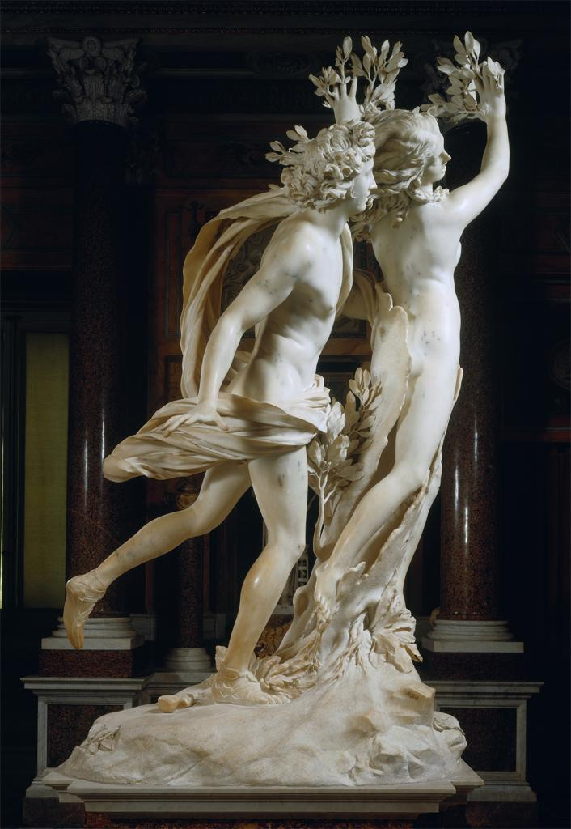

Bernini, *Pluto and Persephone*, 1622-25.

